**Title: Deployment of a Static Restaurant Website using GitHub Pages**

**1. Introduction**

This project focuses on the development and deployment of a static restaurant website using GitHub Pages. GitHub Pages is a free hosting service that allows you to publish web content directly from a GitHub repository.

**2. Requirements**

Before starting, ensure you have the following:

* A GitHub account
* Basic knowledge of HTML, CSS (and optionally JS)
* Visual Studio Code or any code editor
* Git installed on your system
* Internet connection

**3. Step-by-Step Deployment Process**

**✅ Step 1: Create Your Website Locally**

* Develop your restaurant website using HTML, CSS, and optionally JavaScript.

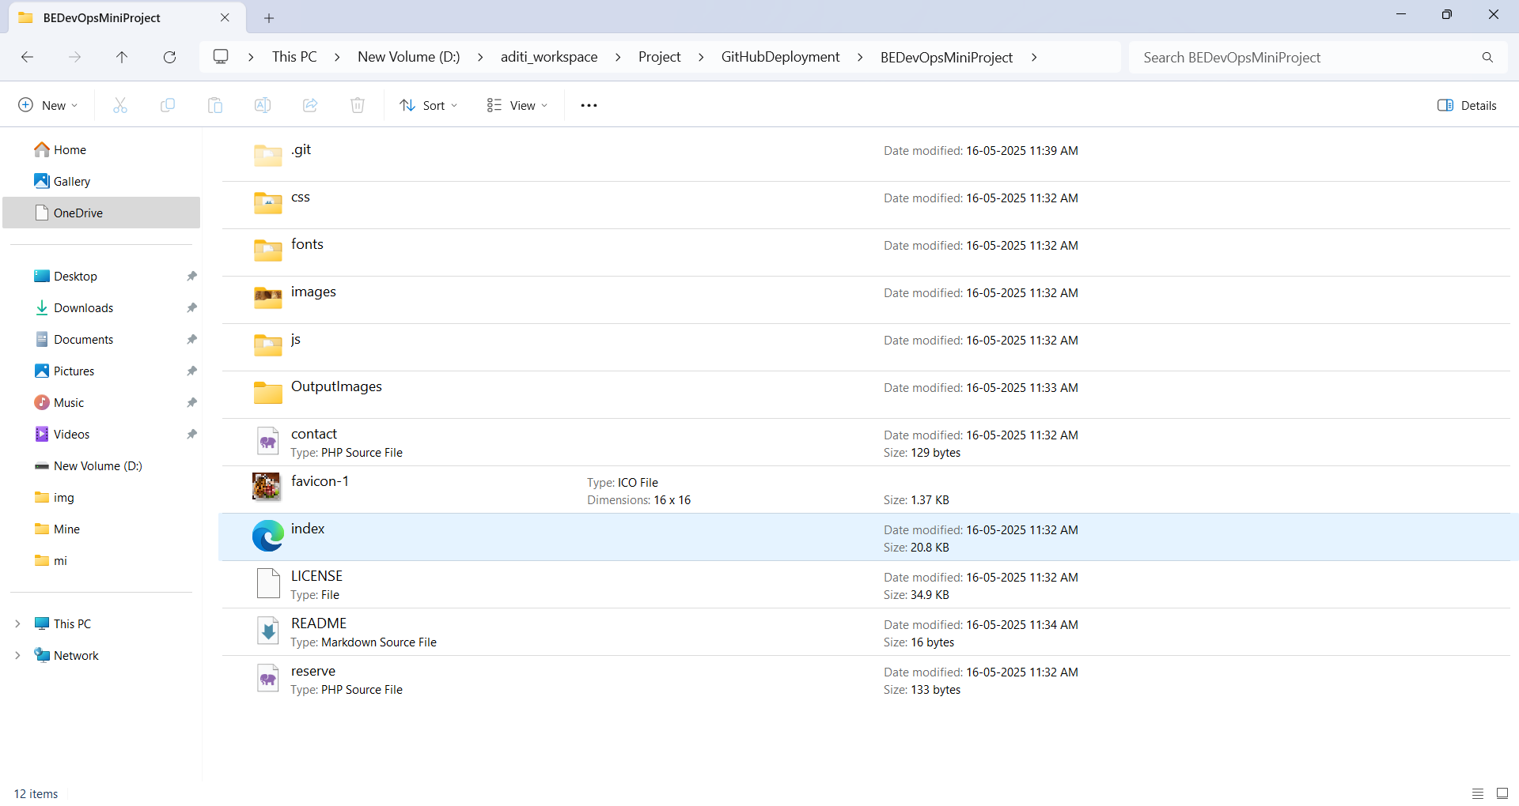

**✅ Step 2: Create a GitHub Repository**

1. Go to [GitHub](https://github.com) and log in.
2. Click on **New Repository**.
3. Name it something like restaurant-website.
4. Keep it public and **do not** initialize with README (you'll push your files later).

**✅ Step 3: Push Your Code to GitHub**

1. Open terminal or Git Bash in your project folder.
2. Run the following commands:

git init

git remote add origin https://github.com/your-username/restaurant-website.git

git add .

git commit -m "commit message"

git push -u origin main

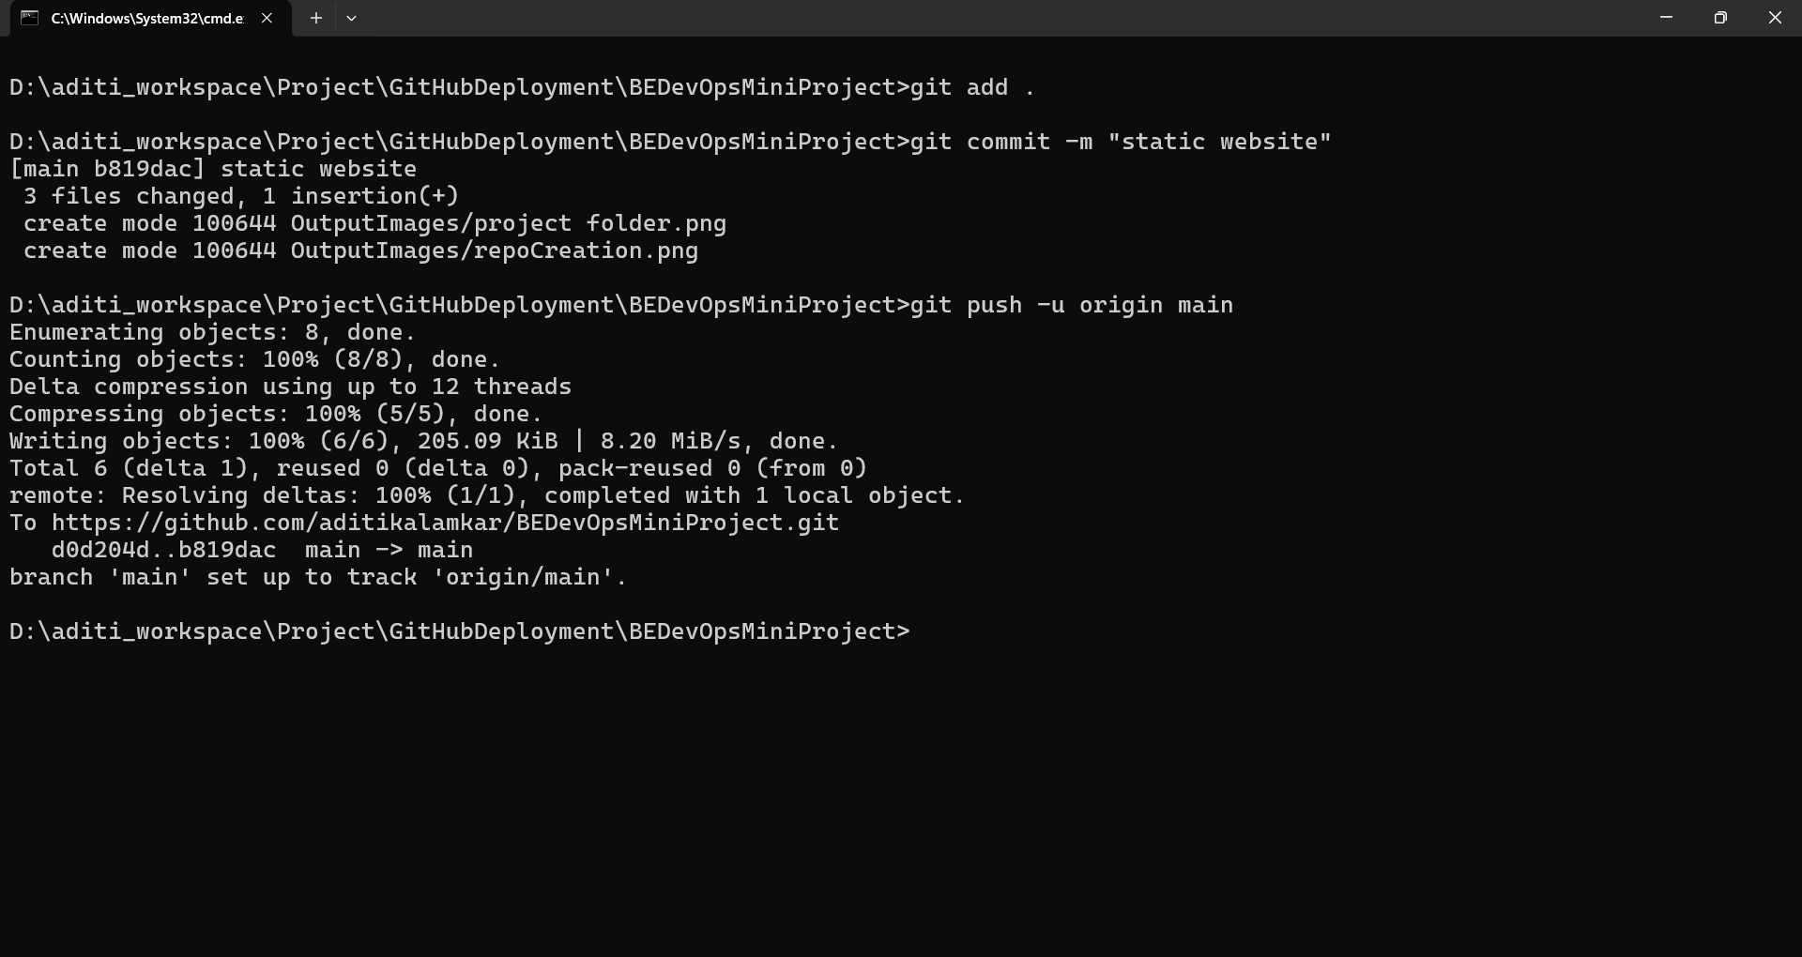

**✅ Step 4: Deploy via GitHub Pages**

1. Go to your repository on GitHub.
2. Click **Settings** > **Pages** (on the left menu).
3. Under **Source**, select main or master branch, then select /root folder.
4. Click **Save**.
5. GitHub will provide you a URL – this is your live website!

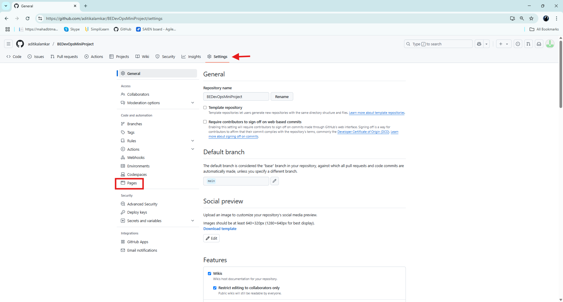

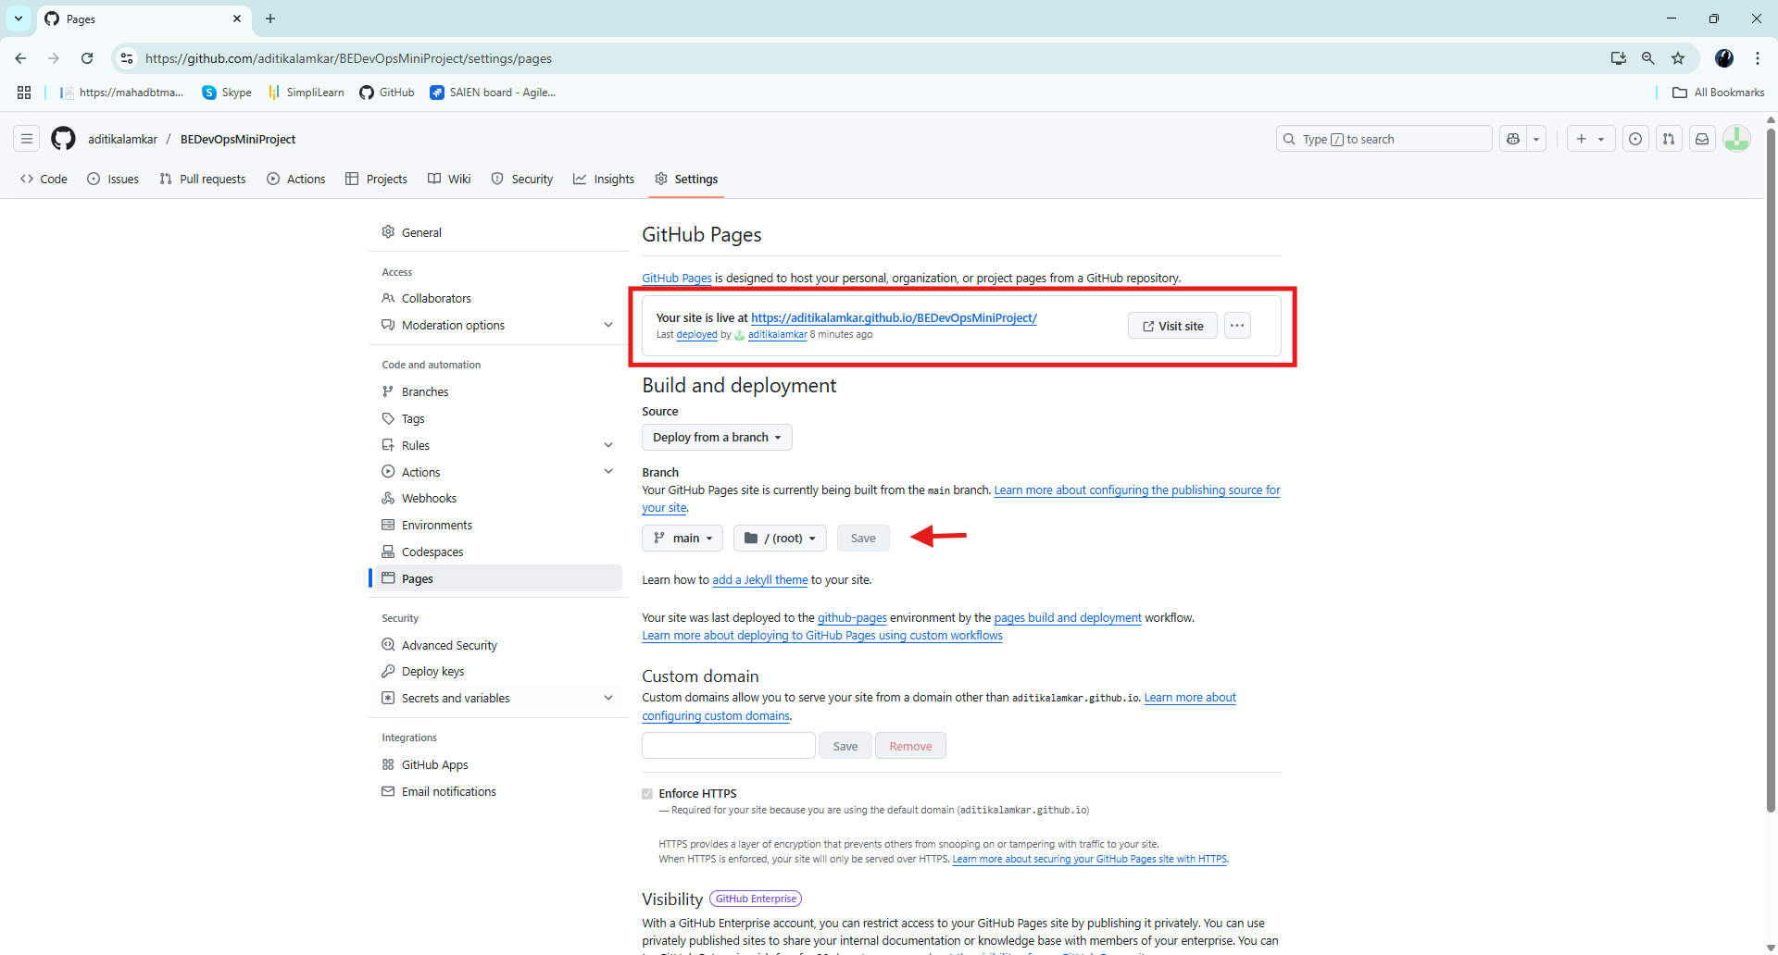

**✅ Step 5: Access Your Website**

* Visit the URL shown under GitHub Pages section.
* Example: <https://your-username.github.io/restaurant-website/>
* <https://aditikalamkar.github.io/BEDevOpsMiniProject/>

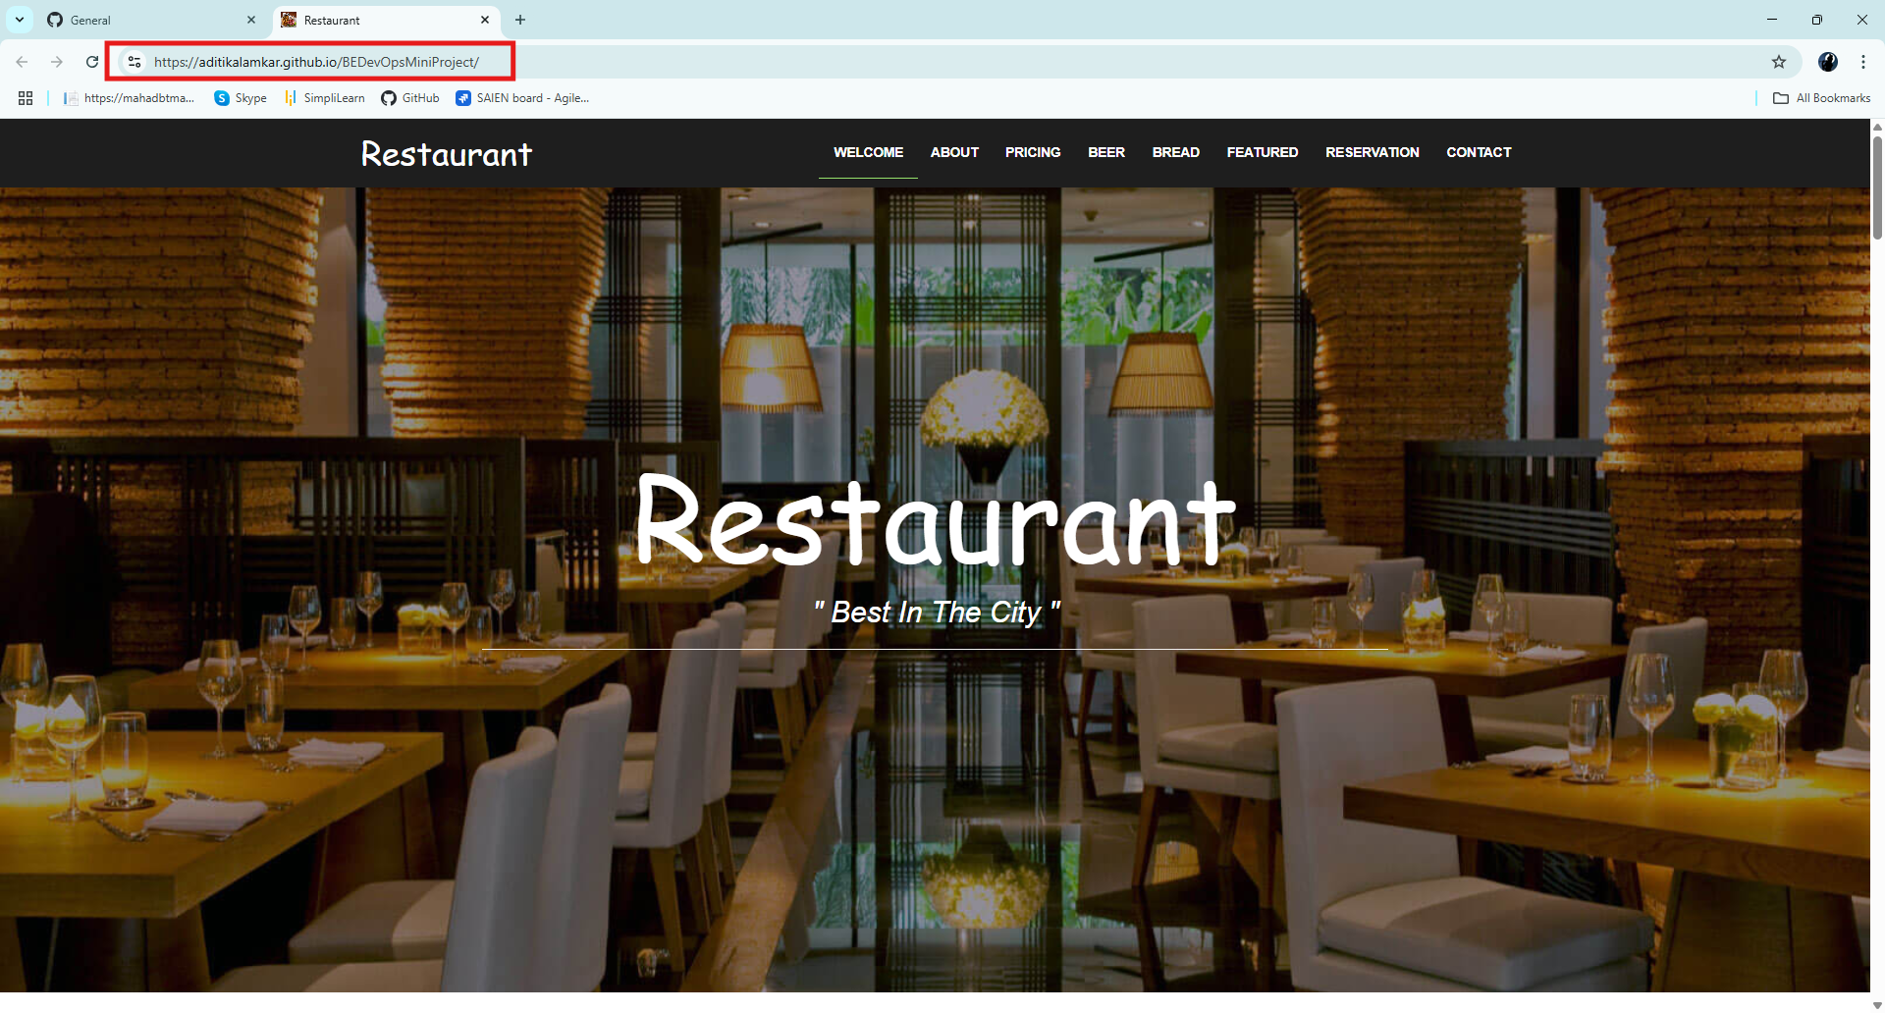

**4. Conclusion**

Using GitHub Pages for hosting static websites is a quick, reliable, and free method. This project demonstrates how a restaurant website can be built and deployed effectively without any backend setup.